

Our Lady and St. Hubert’s Catholic Primary School

Wraparound Club
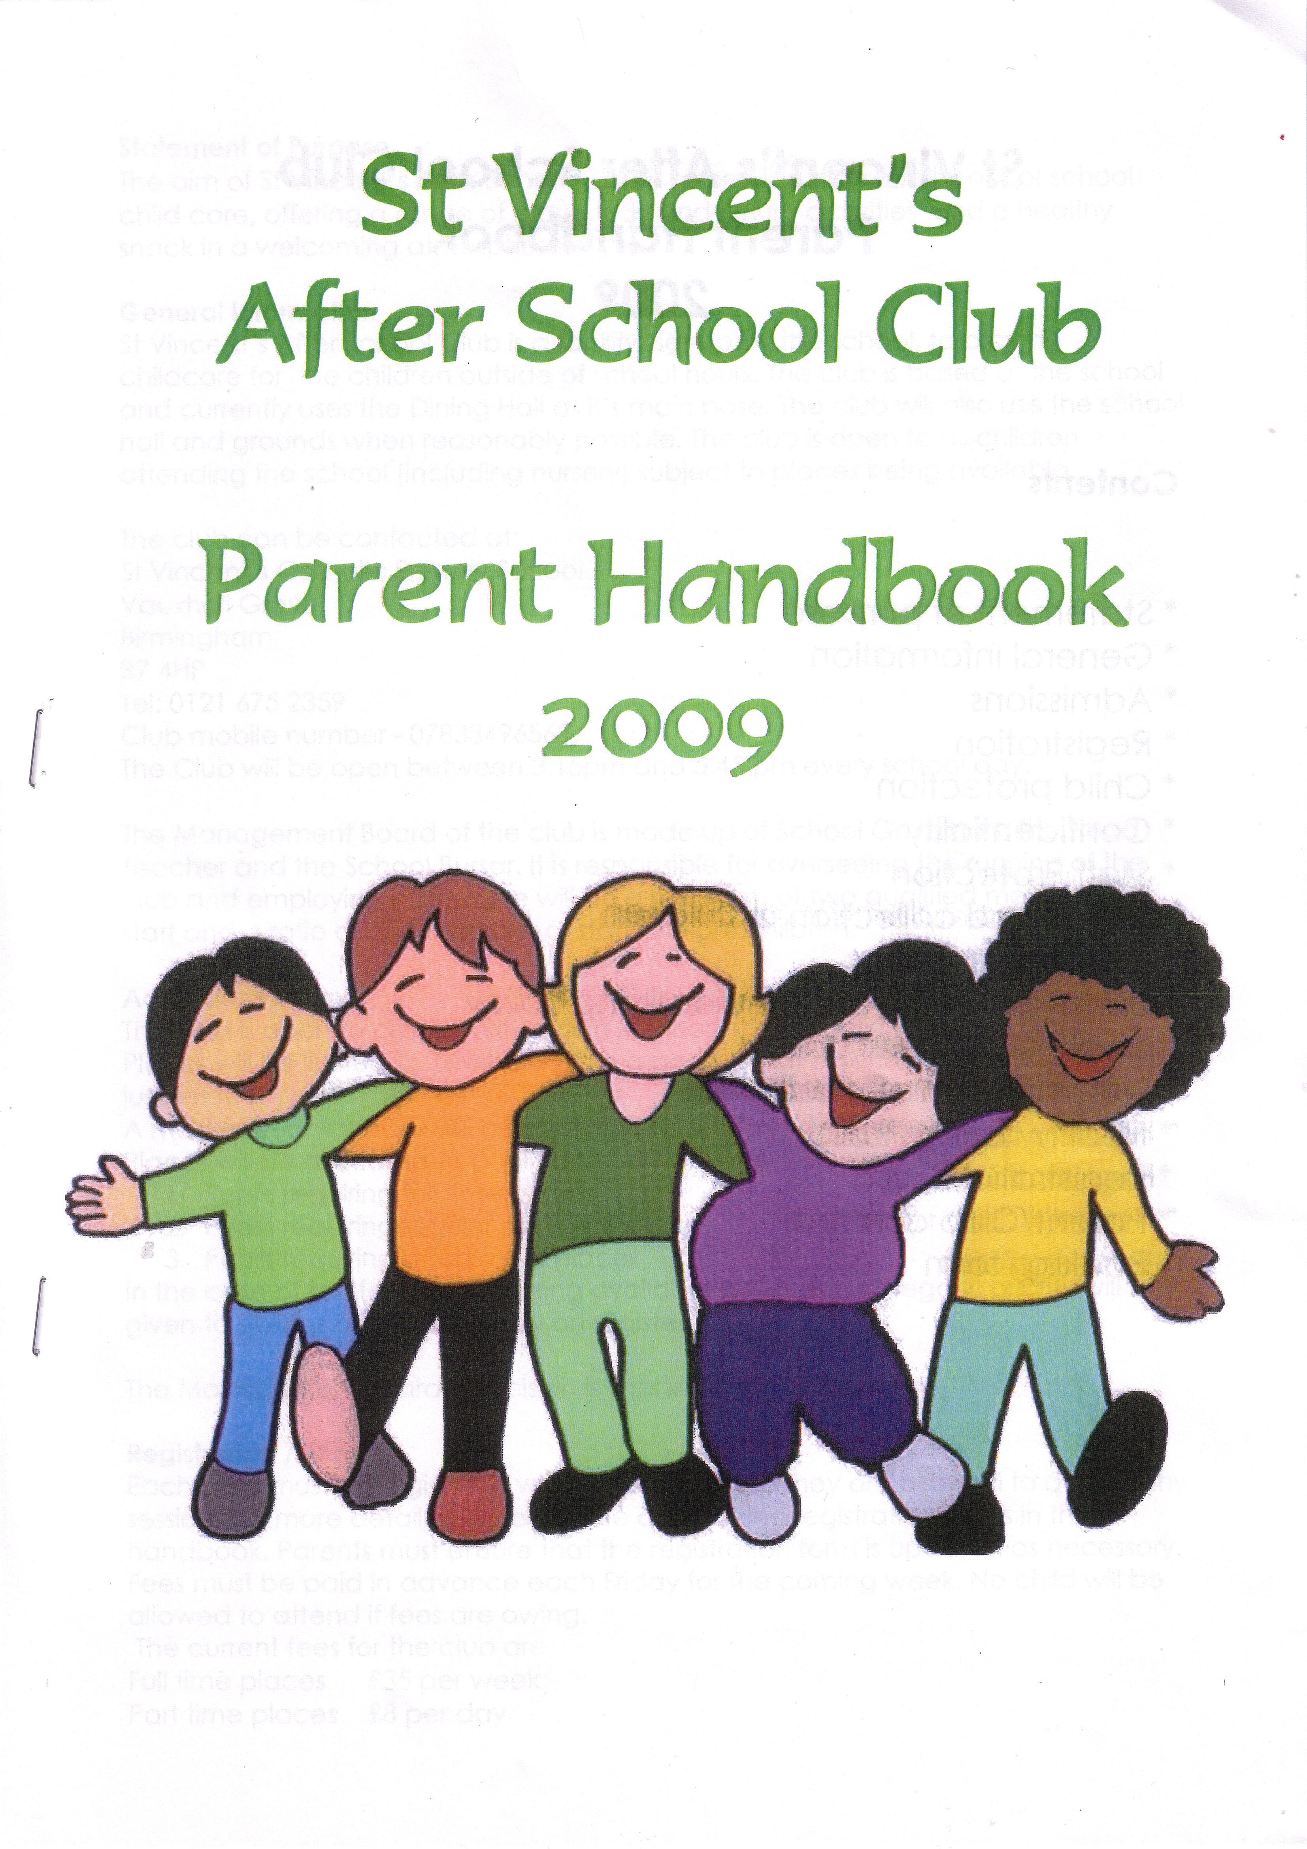

Parent Handbook

Our Lady and St. Hubert’s Catholic Primary School Wraparound Club
Parent Handbook

‘At Our Lady & St Hubert’s, home, school and parish work together as we grow and learn, knowing that God is with us in all we do.’

Contents

* General Information
* Statement of purpose
* Club Information: opening times
* Admissions
* Policies: Safeguarding
Child Protection and
Staff Code of Conduct
* Arrival and Collection Procedures
* Behaviour and Anti-bullying
* Health and Safety
* Healthy Eating
* Complaints Procedure
* Staff Protection
* Registration/Fees
* Terms and Conditions
* Club Agreement
* Booking Form
* Registration forms
* Parent Agreement

General Information

Our Lady and St Hubert’s wraparound club is a facility set-up by the school, to provide childcare for the children outside of school hours. The club is based at the school and uses the school hall for its main base. The club will also use the school classrooms and grounds when reasonably possible. The club is open to all children attending the school subject to places being available and ability to meet the individual needs of pupils.

Statement of Purpose

The aim of Our Lady & St Hubert’s Before and After School Club is to provide high quality out of school child care, offering a range of play, study and leisure activities in a welcoming atmosphere.

Club Information

The club can be contacted at: Our Lady and St Hubert’s Catholic Primary School
Moat Road
Oldbury
B68 8ED
Email: enquiry_olh@emmausmac.com

- Tel: 0121 422 2629. Please use option 2 to speak to a member of the office staff. This is the main school number, parents can use this number between 8am-4.45pm Monday to Thursday and 8am-4.15pm on Friday. The office telephone lines close at 4.45pm Monday to Thursday and 4.15pm on Friday please ensure you telephone before these times to communicate any changes of people collecting or late collections.

Opening Times

The Club is open to children between 7.30am – 8.50am & 3.30pm - 5.45pm every school day. Pre-School wraparound club is open to children between 7.30am – 8.50am and 3.00pm – 5.45pm every school day.

There is a minimum of two qualified members of staff and a ratio of one member of staff to eight children under the age of 5 years.

Wraparound Admissions
The Before and After School Club will admit any child who attends Our Lady & St Hubert’s Catholic Primary School subject to availability of places, and the admissions criteria below.
The Before School Club will accept up to 70 children on any one day subject to staffing. The After School Club will accept up to 70 on any one day subject to staffing. The Pre-School Breakfast Club will accept up to 8 children on any one day subject to staffing. The Pre-School Afterschool Club will accept up to 8 children on any one day subject to staffing. The club operates a minimum staffing of one adult per eight children under the age of 5 years.
We reserve the right to close bookings early due to place availability and staffing.
The club admissions roll is reset for every academic year, during the summer term for the following September.
Admissions of the club is based on the following criteria: -
A. Date registration/request is received by the club.
B. Length of time on waiting list.
C. Bookings depending on available places.
If the club is over-subscribed a waiting list will be maintained, and places offered according to the admissions criteria above.

Policies

The Club follows the school’s policies for:

Safeguarding
Child Protection and
Staff Code of Conduct

Arrival and Collection of Children Policy
Arrival
In the morning, parents drop off their children to the school foyer where a member of the wraparound team will accept the child. Parents should press the wraparound intercom button on the pedestrian gate to speak to a member of the wraparound team to gain access to the school site. Staff take children to their classrooms in the morning. After school, children are taken to the wraparound provision by a member of school staff each day. Parents must inform the club and school, in advance, if their child will not be attending a booked session.
Collection
All children must be collected from the club door (at the top of the school hall) by 5.45pm at the latest. The time will be as measured on the club entrance clock. Late collection will be charged at £1 per minute per child. Regular late collection (defined as three times) will lead to the child’s place being withdrawn.
Parents must give the names of all persons authorised to collect their child on the registration form. Only persons named on this form will be able to take the child from the club unless prior arrangements in exceptional circumstances have been made known to the Wraparound Club Manager.
It is the responsibility of the parent / guardian to ensure that any changes to the named individuals who can collect their child are communicated to the school office both in writing and verbally.

The person collecting a child must approach a club worker so that club workers know who is being collected, and by whom, and can sign the child out.

In the case of a parent/carer failing to collect the child, the Wraparound Club Manager will call the emergency contacts given to come to the Club to take the child home. If the club staff are unable to contact any of the emergency numbers, they will contact Sandwell Children’s Trust – 0121 569 3100 for further advice and support.

If a parent/carer arrives in an “unfit” state, the club staff will contact the police and/or Children’s Services Duty Officer immediately. The safety of the children is always our first priority.

Behaviour and Anti-Bullying

Staff encourage considerate attitudes from all children. Praise and positive encouragement is given to the children where possible. Unacceptable behaviour is always responded to, in private, in an appropriate way, taking full account of the child’s level of understanding. We do not tolerate bullying, intimidation or rudeness. Children are encouraged to resolve conflicts by discussion. However, they should always tell staff if they are hurt or upset. Parents are informed of serious concerns. Persistent unacceptable behaviour will lead to the child’s place being withdrawn.

Health and Safety

The Club promotes the good health of both children and staff by ensuring the highest standards of premises, equipment maintenance and staff awareness in safety matters. There will always be at least one member of staff holding a current First Aid certificate on the premises.

The Club has a first aid box, which is kept out of the reach of children. It is the responsibility of a nominated, qualified first aider within the Club to maintain the contents of the first aid box.

Parents are required to give written consent to Club staff to be able to authorise medical care being given by doctors in an emergency. This will only occur where waiting for parental consent is considered by the doctors to endanger the child’s health and safety. This permission is given as a part of the parent’s contract signed when a child first registers with the Club.

Staff should be aware of any child’s special health conditions. Club staff will administer prescription medicine only to children in accordance with school procedures if written instructions and consent are given by parents. Parents will also be expected to discuss the child’s illness and needs with Club staff prior to any medication being administered.

If a child becomes unwell whilst at the club, parents will be contacted to come and collect the child. All incidents and accidents will be recorded.

Healthy Eating

It is our aim to encourage an interest in healthy eating amongst the children by serving a daily healthy snack. ‘Treats’ may be included from time to time. Children are encouraged but not forced to eat. Water, sugar free squash and fruit are also readily available to the children. Parents should ensure staff are aware of any special dietary requirements. Staff preparing food have a current Food Hygiene Certificate.

Complaints

Any parent wishing to make a complaint should follow the complaints procedure:
- Speak to the Wraparound Club Manager to try to resolve the issue.
- If unresolved, speak to the Business Partner or Principal.
- If still unresolved, please access the complaints policy.

Staff Protection

We believe that our staff have a right to work in a safe environment free from verbal or physical abuse. We work to create and promote good relationships between staff and children and parents. Verbal aggression or unreasonably demanding behaviour towards staff by parents is not acceptable and is likely to lead to withdrawal of a child’s place. Threats of violence will always be reported to the police.
All policies are available from the club and school on written request.

Unacceptable Behaviour on School Premises

Contract – see parent agreement attached.

Each child must be registered with the club before they are allowed to attend any session. For more details, please see the copy of the registration forms in this handbook. Parents must ensure that the registration form is updated as necessary. Fees must be paid at the time of booking sessions through our Arbor app. No child will be allowed to attend if fees remain unpaid.

The current daily fees for the club are: NEWLY REVISED FEES AS OF SEPTEMBER 2024

 | Session Times | Per Child
Morning | 7.30 – 8.50am | £ 6.25
Afternoon 1 hour | 3.30 – 4.30pm | £ 5.75
Afternoon 2 hours | 3.30 – 5.30pm | £9.00
Afternoon 2 hours 15 mins | 3.30 – 5.45pm | £9.50
Pre-School After School Club Fees
Afternoon 1 hour | 3.00 – 4.00pm | £ 5.75
Afternoon 2 hours | 3.00 – 5.00pm | £9.00
Afternoon 2 hours 45 mins | 3.00 – 5.45pm | £9.50
Late charge | £ 1 per minute per child

Fees will be reviewed annually and any changes informed in July for implementation in September.

Our Lady & St. Hubert’s Catholic Primary School

Wraparound Club Agreement

The decision of the Local Governing Body is final in all circumstances.

The aim of the club is to provide quality before and after school care provision for children of Our Lady & St. Hubert’s Catholic Primary School. This includes social and educational activities in a safe and secure environment on the school site. The costs are available on request from the club Wraparound Manager or school office and will be reviewed annually.

The Club is open from 7.30am – 8.50am and 3.00pm – 5.45pm every school day during term time. Children are taken to the wraparound provision by a member of school staff at the end of the school day. The club accommodation comprises of the school hall, pre-school classroom, reception classrooms, toilets and the playground. A light breakfast / healthy snack and drink is served from the club kitchen.

Our Lady & St Hubert’s Wraparound Club agrees that:

- We will provide a safe, relaxed and friendly environment for the children.
- We will provide a range of recreational and educational opportunities.
- We will provide a light breakfast / healthy snack and a drink.
- We will ensure equality of opportunity in all activities.
- The Club will be open from 7.30am – 8.50am and 3.30pm to 5.45pm every school day.
- Pre-School wraparound club will be open from 7.30am to 8.50am and 3.00pm to 5.45pm every school day.
- In the morning, we will deliver children to their classes each day by 8.50am.
- After school, the children will be bought to the wraparound provision by a member of the school staff.
- Children will be handed over at the end of each session, only to the adult(s) who have been identified on the record card.
- If a child becomes ill whilst attending a session, we will inform the named contact and the child will be looked after until collected.
- Medicines will only be administered according to the school medicines policy.
- We will try and arrange alternative cover in the case of staff absence.
- We will treat all children as individuals and endeavour to meet their specific needs.
- We will take account of each child’s special dietary needs.
- We will not allow any behaviour that is likely to affect the safety and enjoyment of others.
- Any incidents of poor behaviour will be dealt with in accordance with our behaviour policy.
- Persistent poor behaviour will lead to the place being withdrawn.
- We will make sure that all parents/carers are aware of any changes to the Club’s
policies and procedures.
- We will act on any complaint as explained in our complaints procedure.

Parents/Carer’s agree to: -

- Complete and sign your child’s registration form.
- Book and pay for your child’s place one month (or more) in advance.
- Ensure your child is collected by a person named on the registration from, from the internal club door.
- Collect your child on time.
- Inform us if your child will not be attending a booked session, club telephone number - 0121 422 2629 option 2.
- Pay for all booked sessions including those where a child cannot attend e.g. through illness
- Regularly update us of any changes to the registration form e.g. address, home telephone no, work telephone no, and medical needs etc.
- Keep us informed of any changes that may affect your child’s well-being.
- Park safely around school – and not on the red route between the given times.
Application
- A child cannot be admitted until the following forms are completed
child’s registration form
parent agreement
- Application packs are available from the School Office.
Bookings and Payments
- All bookings and payments should be made through school’s Pupil Management System, Arbor.
- Parents must make ensure all bookings are made a month in advance for all wraparound sessions. Bookings will need to be completed before the 1st day of the following month.
- Parents whose requirements will change from week to week should book as far in advance as possible to secure their places.
- Once sessions have been booked, they are chargeable and NO CREDIT will be given for absence.
- Fees should be paid via Arbor at the time of booking.
Children will not be able to attend if fees have not been received.
- A fee of £1 per minute will be charged for late collection per child. Regular late collection (defined as three times) will lead to the child’s place being withdrawn.
- Charges will be reviewed in June each year to be applied from the following September. Parents of children attending the club will be advised of the outcome of the review in July each year.
Payment can be made by:
- Child Care Vouchers
- Arbor

Parent Agreement
I have read the above information relating to Our Lady & St Hubert’s Catholic Primary School Wraparound Club and agree to abide by the stated terms and requirements.

Signed ________________________________________________________________

Print name ________________________________________________________________

Parent /carer of ____________________________ D.O.B. ________________ Class _______

Parent /carer of ____________________________ D.O.B. ________________ Class _______

Parent /carer of ____________________________ D.O.B. ________________ Class _______

Parent /carer of ____________________________ D.O.B. ________________ Class _______

Date ________________________________________________________________

- - - - - - - - - - - - - - - - - - - - - - - - - - - - - - - - - - - - - - - - - - - - - - - - - - - - - - - - - - - - - - - - - - - - - - - - -

Received by ________________________________________________________________
Date: ________________________________________________________________

Our Lady & St. Hubert’s Catholic Primary School
Wraparound Club

Childs Registration Card
Name of child (and any other name by which child is known)

Date of Birth |  | Ethnic Origin
Gender | M / F | Religion

Childs first language
Disabled (Y/N)
Access Requirements (please specify)

Name of Parent(s)/Carer

Childs home address and home telephone number/mobile number

Parent(s)/carer work address(es), and telephone number
Telephone Number: | Telephone Number:

Other persons authorised to collect child
Name | Relationship to Child | Telephone Number
Other Emergency contacts
Name | Relationship to Child | Telephone Number

Dietary Requirements
Does your child have any special dietary needs e.g. vegetarian? __ Yes __ No
Please give details

Medical Information
Does your child have any known medical conditions or allergies? __ Yes __ No
Please give details

Name Address and telephone number of child’s doctor

I consent to any emergency medical treatment necessary during the running of the club. I understand that in an emergency every effort will be made to contact me. If there is a delay which would endanger my child’s health and safety, I authorise the club staff to sign any written form of consent required by hospital authorities.

Yes No

I consent to my child taking part in all normal club activities including outdoor games.
__ Yes __ No
I consent to photographs being taken of my child for use within the school/club.
__ Yes __ No
I consent
I consent to photos/videos of my child being used for the school website, twitter and face book page book page. In line with the E-safety Policy.
__Yes __No

Signed (Parent/Carer) _______________________________________________________
PRINT NAME(S) _______________________________________________________
DATE _______________________________________________________

